|  |  |
| --- | --- |
| Image result for Tech Meetup  Project Report  Submitted By: Chetan Sharma |  |

Table of Contents

Project Proposal 2

Goals and Objectives 2

Project Scope 2

Project Deliverables 2

Project Specifications 2

Target Audience 3

Project Tasks and Milestones 3

Resource Requirements 4

Project Assumptions 4

Analysis Report 4

Requirements Analysis 4

Detail Design 5

Home Page 5

Login Page 5

Admin Meetup Page 6

Admin Meetup Registration Page 7

Admin Participant Page 8

User Meetup Page 9

User Participation Page 10

User Participation Confirmation Page 10

Project Testing 11

Usability Testing 11

Testing 11

User Manual 12

Admin Setup 13

User Access Levels 13

# Project Proposal

## Goals and Objectives

The main aim of this project is to develop an online web application called “Tech Meetups” With the help of the web app user can register for events around and can participate in various events and can check their details such as for which events they are registered. New Users can register to access the meetups. Moreover, admin can add new events, edit and delete the existing events. Also, admin can delete registration and can access the details of registrations. Admin has right to edit, delete and access details of the participants for the events.

## Project Scope

This project is 4 weeks long which means 20 days of total to complete the project. The scope of this project is to help people connect with tech events and to bring awareness about the most famous and demanding events.

## Project Deliverables

Following table states the deliverables for the project:

|  |  |
| --- | --- |
| **Deliverable** | **Description** |
| Planning | This defines the planning and specification for the project. |
| Design and Code | This will include the design and coding part of the project. |
| Implementation and Testing | This will demonstrate how the web application can be used and testing details of the project. |
| Final Documentation | This will provide the final documentation of the project. |

## Project Specifications

* Admin can login/logout successfully.
* Valid username and passwords are allowed
* Admin can add, edit, delete events.
* Admin can edit, delete and access details of participants
* Admin can delete and access the registration.
* User can login/logout successfully,
* New User can register successfully
* User can participate in Events
* User can register for events and check details of the events.
* Admin can register new admin.

## Target Audience

Users who are keen to know more about new technologies are the target audience for the project.

## Project Tasks and Milestones

Project Tasks and Milestones are as below:

|  |  |  |  |  |  |  |  |  |  |  |  |  |  |  |  |
| --- | --- | --- | --- | --- | --- | --- | --- | --- | --- | --- | --- | --- | --- | --- | --- |
| **Stages** | **Activities** | **Duration**  **Week1-2** | | | | **Duration**  **Week-2-3** | | | | | **Duration**  **Week-3-4** | | | | |
| Project Planning | Research on technologies |  |  |  |  |  |  |  |  |  |  |  |  |  |  |
| Start of Meeting |  |  |  |  |  |  |  |  |  |  |  |  |  |  |
| Project Proposal and documentation |  |  |  |  |  |  |  |  |  |  |  |  |  |  |
| Project Execution | Database Design |  |  |  |  |  |  |  |  |  |  |  |  |  |  |
| User Interface Design |  |  |  |  |  |  |  |  |  |  |  |  |  |  |
| Identity Framework implementation |  |  |  |  |  |  |  |  |  |  |  |  |  |  |
| Admin Interface |  |  |  |  |  |  |  |  |  |  |  |  |  |  |
| User Interface |  |  |  |  |  |  |  |  |  |  |  |  |  |  |
| Testing |  |  |  |  |  |  |  |  |  |  |  |  |  |  |
| Final | Documentation and final report |  |  |  |  |  |  |  |  |  |  |  |  |  |  |

## Resource Requirements

Following technologies and development method:

* Asp.net MVC Framework and Identity framework- ASP
* Windows Operating System, 64-bit Processor and 4 to 8 GB RAM, MS Word

## Project Assumptions

The following are the identified high-level risks that might affect the completion and success of the project:

* Cascading delays in other based tasks can cause project delays.
* The size and length of the project may be underestimated.
* Exceptional device protection should be given to the company, which includes confidential information.
* The total required functionalities can go beyond what the designer can produce in the available time.

# Analysis Report

### Requirements Analysis

The requirement analysis covers the functional and non-functional aspects of the system.

#### Functional and Non-functional Requirements

|  |  |
| --- | --- |
| **Functional Requirements** | **Non-Functional Requirements** |
| Login/ Logout | The web app should work in all browsers and devices |
| Events add, update, edit, delete check detail as admin | Performance and load time should be fast |
| Registration delete and access by admin | Web app should be secure |
| Participants edit, delete and access by admin | Admin should have full access to the system |
| User can login/logout | Normal user should have limited access to the system. |
| User can register for events and check details |  |

## Detail Design

### Home Page

This is main landing page of the Web application. On the Navigation bar of this page there are menu options such as Home, Meetups, Sign up Participants, Register a Meetup Admin and Login.



### Login Page

This Page is helpful for both Admin and users to login to the application by using their credentials.

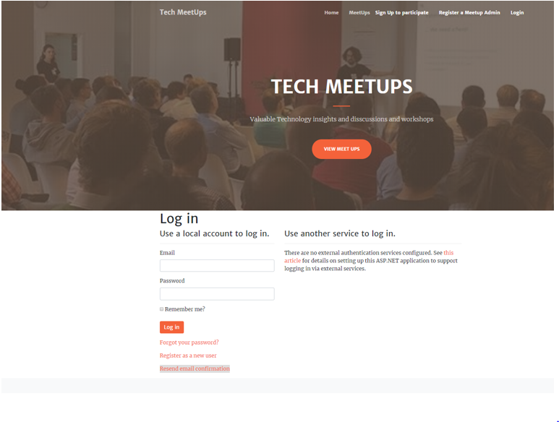

### Admin Meetup Page

This page will highlight the details of all Events. An Admin can create new events. Also, can edit and delete events.

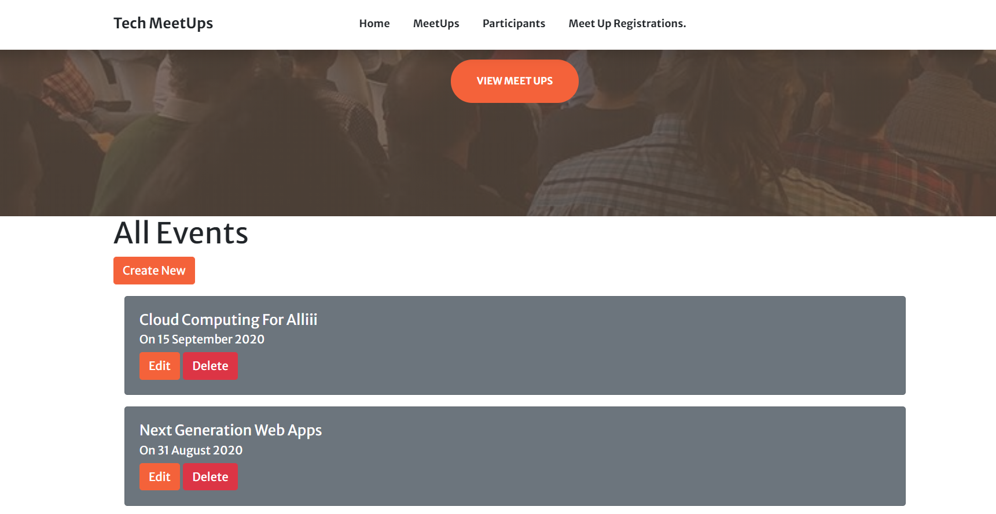

### Admin Meetup Registration Page

With the help of this page admin can delete meetup registrations and can access the details of the meetups.

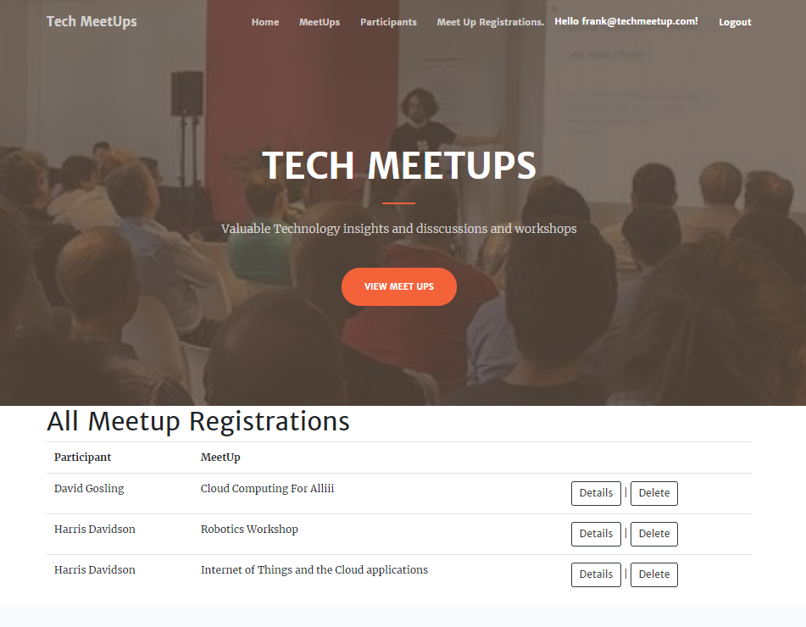

### Admin Participant Page

This page will highlight the details of the participants who have registered for the events. Admin can access, edit and delete the participants.

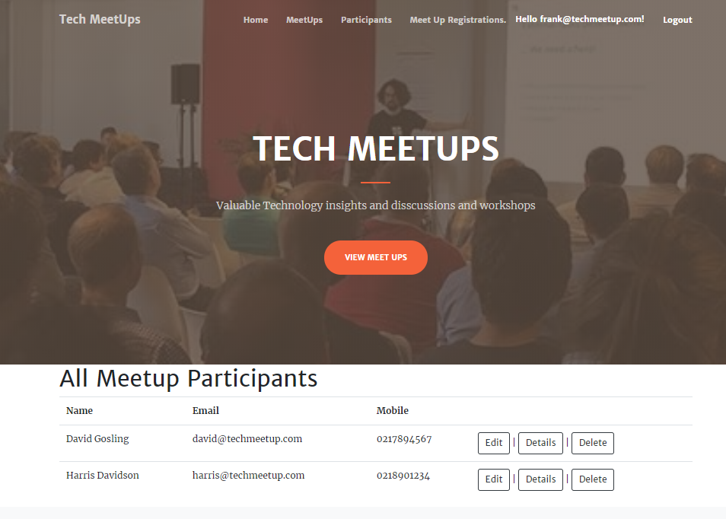

### User Meetup Page

This page will highlight all the events to the user and user can participate in the events by clicking on the participate option.

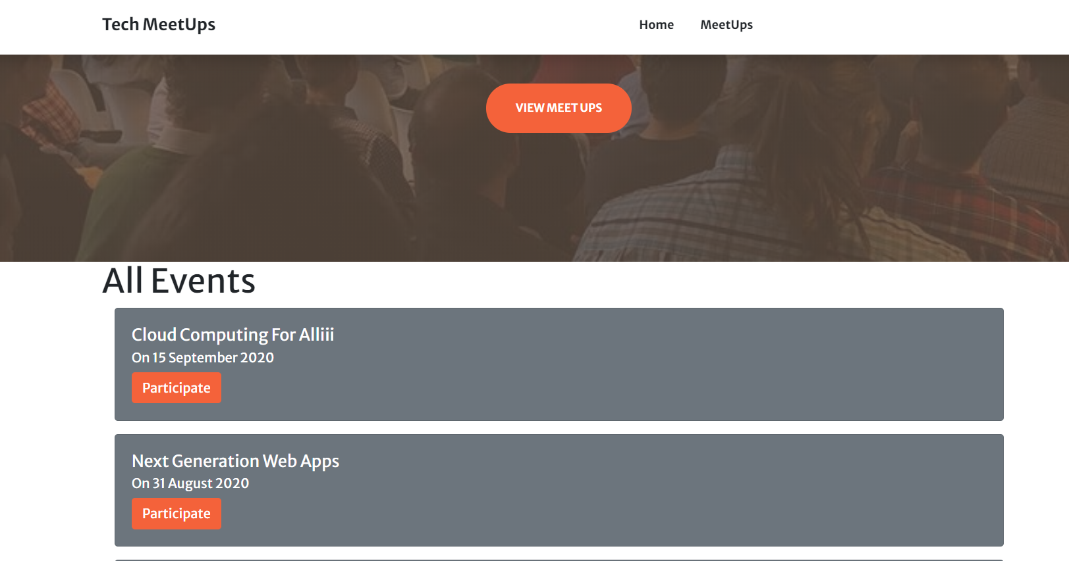

### User Participation Page

This page will highlight the details of the events and user can confirm the participation for a particular event.

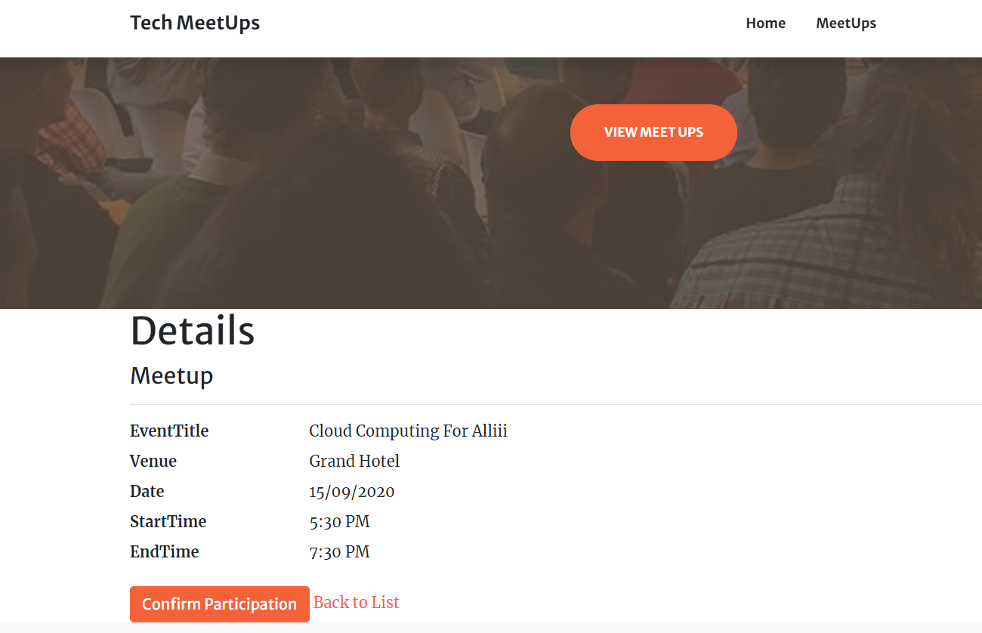

### User Participation Confirmation Page

When user will click on confirm Participation, he/she will be redirected to the confirmation page, where user will be confirmed as registered for the meetup event.

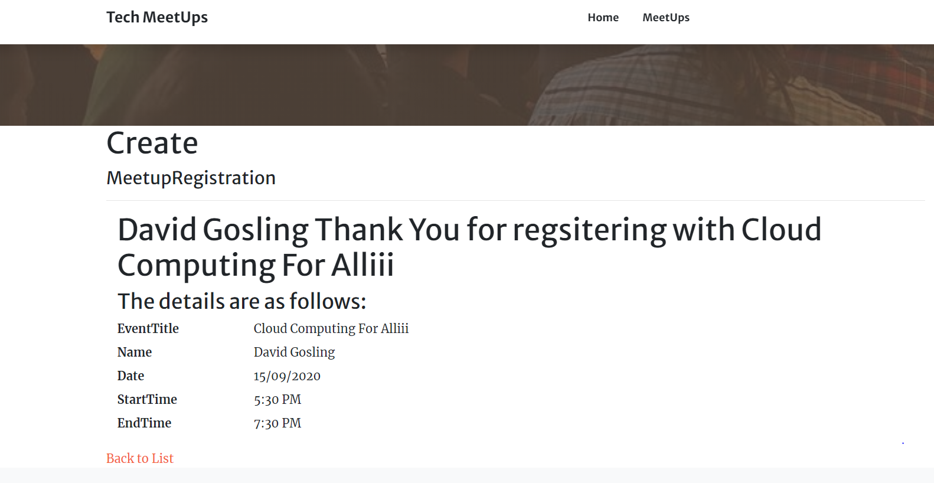

# Project Testing

## Usability Testing

### Testing

**Tester 1**

|  |  |  |  |  |  |  |
| --- | --- | --- | --- | --- | --- | --- |
| **Tester – 1** | | **Scale** | | | | |
| **No.** | **Question** | **Strongly Disagree (1)** | **Disagree (2)** | **Normal (3)** | **Agree (4)** | **Strongly Agree (5)** |
| 1 | I will use the system frequently |  |  |  |  |  |
| 2 | Is the system complex? |  |  |  |  |  |
| 3 | Is it Easy to use? |  |  |  |  |  |
| 4 | I think technical support is required to run the system |  |  |  |  |  |
| 5 | I found the various functions in this system were well integrated |  |  |  |  |  |
| 6 | I thought there was too much inconsistency in this system |  |  |  |  |  |
| 7 | Most people would learn to use this system very quickly |  |  |  |  |  |
| 8 | I found the system very bulky to use |  |  |  |  |  |
| 9 | I felt very confident using the system |  |  |  |  |  |
| 10 | I needed to learn a lot of things before I could get going with this system |  |  |  |  |  |

**Tester 2**

|  |  |  |  |  |  |  |
| --- | --- | --- | --- | --- | --- | --- |
| **Tester –2** | | **Answer Scale** | | | | |
| **No.** | **Question** | **Strongly Disagree (1)** | **Disagree (2)** | **Normal (3)** | **Agree (4)** | **Strongly Agree (5)** |
| 1 | I will use the system frequently |  |  |  |  |  |
| 2 | Is the system complex? |  |  |  |  |  |
| 3 | Is it Easy to use? |  |  |  |  |  |
| 4 | I think technical support is required to run the system |  |  |  |  |  |
| 5 | I found the various functions in this system were well integrated |  |  |  |  |  |
| 6 | I thought there was too much inconsistency in this system |  |  |  |  |  |
| 7 | Most people would learn to use this system very quickly |  |  |  |  |  |
| 8 | I found the system very bulky to use |  |  |  |  |  |
| 9 | I felt very confident using the system |  |  |  |  |  |
| 10 | I needed to learn a lot of things before I could get going with this system |  |  |  |  |  |

# User Manual

In “Tech Meetups” web app user can register for events around and can participate in various events and can check their details such as for which events they are registered. New Users can register to access the meetups. Moreover, admin can add new events, edit and delete the existing events. Also, admin can delete registration and can access the details of registrations. Admin has right to edit, delete and access details of the participants for the events.

### Admin Setup

* Admin needs to login using the valid credentials.
* If need to add a new admin, firstly the existing admin will login and register the new admin.

### User Access Levels

Only registered users can access the features of Meetup Application

* Admin: Full access to the system and all functionalities
* Users: Limited access to the app.